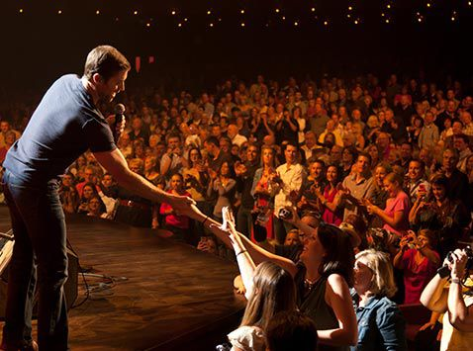
What began as a simple radio broadcast in 1925 is today a live entertainment phenomenon. Dedicated to honoring country music’s rich history and dynamic present, the Grand Ole Opry showcases a mix of country legends and the contemporary chart-toppers who have followed in their footsteps. The Opry – an American icon and Nashville, Tennessee’s number-one attraction – is world-famous for creating one-of-a-kind entertainment experiences for audiences of all ages.
It’s been called the “home of American music” and “country’s most famous stage.” Every year, hundreds of thousands of people make pilgrimages across town or around the world to the Grand Ole Opry to see the show live. Millions more tune in to Opry broadcasts via a mobile app, SiriusXM Satellite Radio, Nashville’s 650 AM WSM, and the Opry website and WSM 650 AM website.
It began on the night of Nov. 28, 1925, when an announcer on Nashville radio station WSM introduced fiddle player Uncle Jimmy Thompson as the first performer on a new show called "The WSM Barn Dance." Now, more than 80 years later, the show Hay started is still going strong. Along the way, it has launched countless country music careers and led the way for Nashville to become Music City.
Early Opry performers such as Roy Acuff, Minnie Pearl, Ernest Tubb, and Bill Monroe became musical foundations for the Opry during its years in residence at the historic Ryman Auditorium, later welcoming to the stage artists who would become entertainment icons in their own right including Loretta Lynn, Dolly Parton, and Bill Anderson.
The Opry said goodbye to the Ryman Auditorium on Friday, March 15, 1974 to take up residence at the newly built Grand Ole Opry House. The next night, President Richard Nixon joined Roy Acuff on stage at the Grand Ole Opry House. Still, they could keep in touch with the traditions of the Ryman because a six-foot circle of hardwood was taken from the Ryman and placed center stage at the Opry House.
Today the magic continues. Trace Adkins, Dierks Bentley, Vince Gill, Martina McBride, Brad Paisley, Ricky Skaggs, Marty Stuart, Alison Krauss, and Carrie Underwood are among the stars who are part of the Opry family. Thousands of people make pilgrimages every year to see and hear them, while millions tune in to enjoy the Opry via 650 AM WSM, Sirius XM Satellite Radio, syndicated radio, or opry.com.
Unforgettable moments happen at the Opry every week… Moments like the night Opry legend Little Jimmy Dickens scaled a kitchen ladder to invite Trace Adkins to become an Opry member, or the night Carrie Underwood brought down the house with her rendition of the Tammy Wynette classic, “Stand By Your Man”, or the evening Vince Gill invited jazz vocalist Diana Krall to the stage for an impromptu duet.
Many of those “Opry Moments” are the result of country music’s new stars, superstars and legends taking the same stage on the same night performing a wide variety of musical styles.
During any given Opry show, audiences can expect the best in country, bluegrass, comedy, gospel, and more performed by Country Music Hall of Famers, Opry members who helped establish the Opry as the home of country music, revered superstars, and rising stars just starting to make names for themselves.
The Opry’s member roster reads like a who’s–who of country music and includes Bill Anderson, Dierks Bentley, Garth Brooks, Vince Gill, Alan Jackson, Patty Loveless, Loretta Lynn, Martina McBride, Lorrie Morgan, Old Crow Medicine Show, Brad Paisley, Dolly Parton, Darius Rucker, Ricky Skaggs, Connie Smith, Marty Stuart, Trisha Yearwood, Carrie Underwood, Keith Urban, and many more.

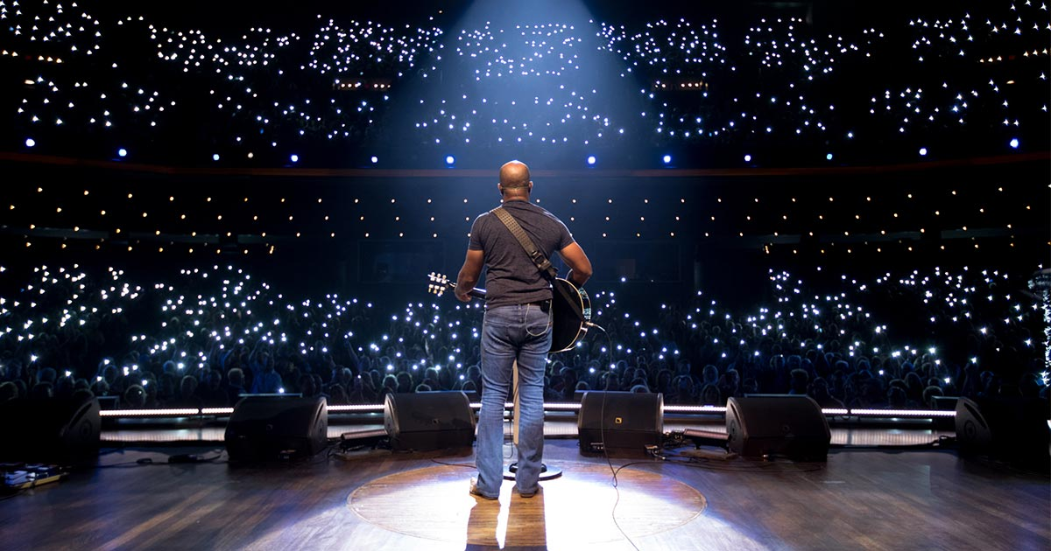GRAND OLE OPRY
▾
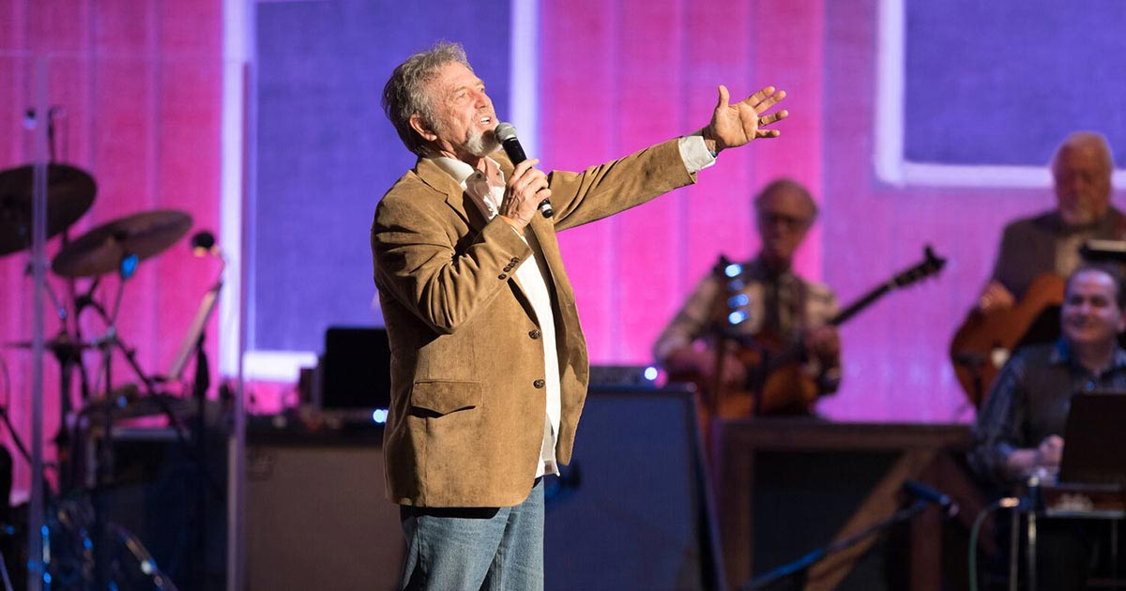OPRY COUNTRY CLASSICS
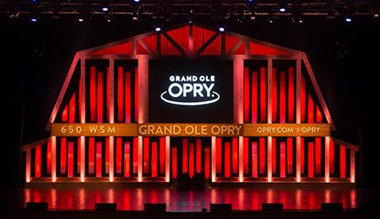
GRAND OLE OPRY HOUSE
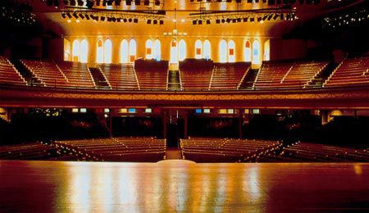
OPRY AT THE RYMAN

